## Set Up and Configuration

### Connecting to bluetooth

Different Bluetooth™ settings are included with the robot, and the one you use depends on your operating system (e.g., Windows, Mac, or Linux). To configure the mode, generally do one of the following steps:

* On the taskbar, select the **Network** icon. Select the **Bluetooth** quick setting to turn **On.**
* Select **Start** > **Settings** > **Bluetooth & devices**, then turn **Bluetooth** on.

To power on your robot, place Bot Marley on the charging dock. The green LED on the dock will light up to indicate successful connection, and a blue light will shine through the Faceplate (see Figure 3) to indicate that Bluetooth is active on the robot.

### Downloading the latest firmware

To ensure your robot is up to date, download the latest firmware package from

**edu.irobot.com/create3-latest-fw.**

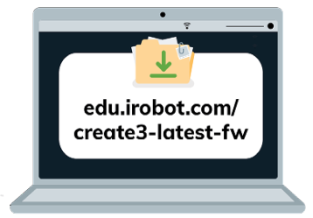

*Figure 1: Latest firmware for Bot Marley*

While Bot Marley is on the charging dock, press and hold Buttons 1 & 2 to activate Bot Marley’s access point. The Light Ring will show spinning blue.

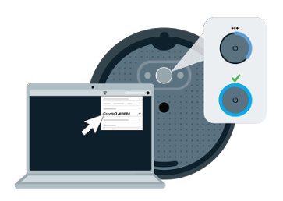  
*Figure 6: This will disconnect your device from the internet temporarily*

Open your computer’s Wi-Fi menu and connect Bot Marley listed as Create-[xxx]. Once connected, Bot Marley’s light ring will glow solid cyan. If you’re unsure as to how to do this, feel free to ask staff for assistance or read this document: [Configuring Bot](https://waikatouniversitynz-my.sharepoint.com/:w:/r/personal/jessica_turner_waikato_ac_nz/Documents/Outreach/CSNeT/CSNeT/2024/(L4)/Configuring%20Norbert.docx?d=wdc1dbd3bd7fd426da60301c122806123&csf=1&web=1&e=jgmkyk) Marley

Once ready, your computer should reconnect to your default Wi-Fi network. The Light Ring will glow solid white and Bot Marley will play its ‘Happy Sound’ when the update is complete.